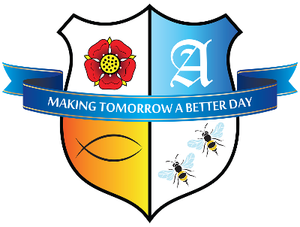
St. Anne’s R.C. Primary School
Feilden Street, Blackburn, BB2 1LQ Tel: (01254) 580462
Email: Office@StAnnes.blackburn.sch.uk Website: www.stannesblackburn.co.uk
Facebook: www.facebook.com/stannesrcprimary Twitter: @stannesrcps IoS / Android App: TheSchoolApp
Headteacher: Mr. A. Pierce

12 February 2025,

Dear Parents and Carers,

As the Sacrament of Reconciliation is fast approaching, I thought it would be helpful to remind you of the date/time.

Reconciliation will take place at St Anne’s Church on Thursday 6th March 2025 at 6pm. We politely ask that children attend in their school uniform. School expect that at least one parent or guardian stays with their child during the sacrament. When it is their turn to talk with Father Jim, they will do this independently.

Below is what they will say at first confession so please practice with them at home.

(You will begin for first confession by saying…) Forgive me father for I have sinned, this is my first confession.

My sins are…. (then tell Fr Jim your sins, remember he can’t tell anyone and you only need two or three).

(Fr Jim will then say a special prayer forgiving you and ask you to say your sorry prayer)
O God, because you are so good, I am very sorry that I have sinned against you, but with the help of your grace I will not sin again.
Amen.

Thankyou, as always, for your continued support and if you have any questions, please ask.

Yours sincerely,

Miss Lee
Assistant Headteacher



